**MODULE 5 ASSIGNMENT**

**DATA MODIFICATION**

**PROBLEM 1 :**

**1. MODIFICATION STATEMENT :**

**C:\Users\Hp\Contacts\Desktop\datawarhousing course\21.PNG**

**2. BEFORE THE MODIFICATION STATEMENT (4 ROWS) :**

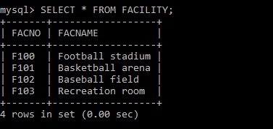

**3. AFTER THE MODIFICATION STATEMENT (5 ROWS) :**

